WEEK – 6 Assignments
React
Mandatory hands-on :-
1. ReactJS-HOL :
Objective :
In this hands-on lab, you will learn how to:
· Set up a react environment
· Use create-react-app
Created react app:
Code :
App.js :
function App() {
return (
<h1
style={{
textAlign: "center",
marginTop: "40px",
fontFamily: "Arial, sans-serif",
}}
>
Welcome to the first session of React
</h1>
);
}
export default App;

OUTPUT :
npm start :
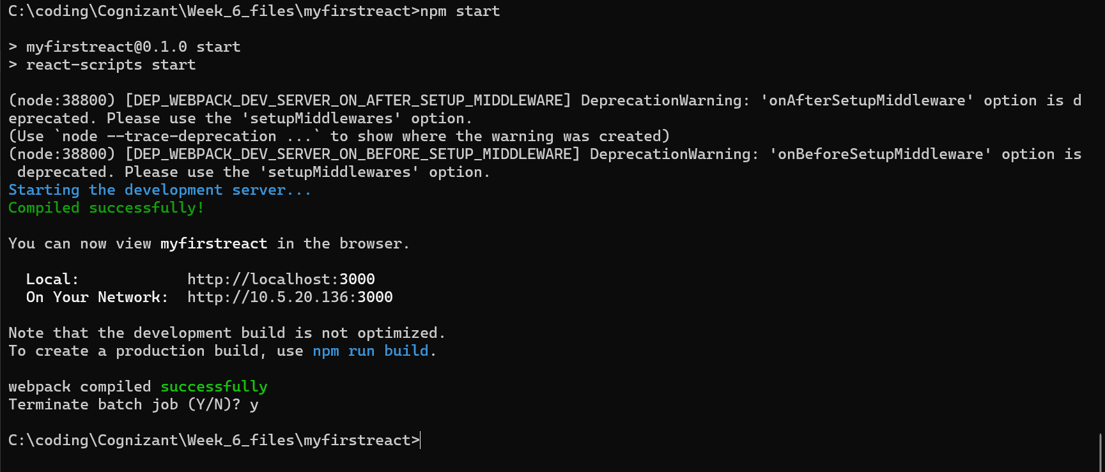

Localhost:3000 :
